THE TITLE OF THE PRESENTATION (12 PT FONT SIZE, ARIAL, CAPITAL LETTERS), AFTER THAT A BLANK ROW (12PT), SIMPLE LINE-SPACE, WITHOUT INTERVAL

Name of the authors¹, Presenter underlined², (10pt, Times New Roman)
¹Name of the workplace with address (8 pt Italic, center aligned, Times New Roman)
²Name of the workplace with address (8 pt Italic, center aligned, Times New Roman)
No blank line or interval should be left between the items, only one blank row (8 pt) after the last one

Here comes the main text, preferably only with a minimal amount of pictures and equations, Times New Roman, 9,5 pt, justified, 1,5 line-space.
We would like to draw your attention to that the abstract book of the conference will be printed in black-and-white therefore please be careful with the attached pictures and diagrams. Furthermore please note that the maximum size of the abstract is one page, including the pictures. Because of that only attach pictures that are strongly connected and essential for the understanding. Please find the form of attaching pictures below.
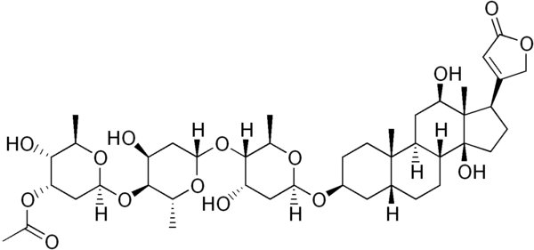

Fig. 1. Title (The title must be Italic, center aligned.) Both the picture and the title must be center aligned, without indentation, simple line-space. One blank row must be left between the title and the picture.
All abstracts must be submitted as described above, otherwise they will be rejected!
References: (8pt, simple line-space)
[1] Name of the authors (separated with semicolon, with semicolon after the last name as well); place of publication (full name of the journal), year of publication, (issue), page-page.
for example:
[2] Ireland, R. E.; Mueller, R. H.; Journal of American Chemical Society, 1972, (94), 5897-5898.

